CABINET MINUTES
January 6, 2009

Present: IC Green, VCs Nowak, Sehr, Tharp, and Sarratore, Director of HR Jerre Fercho

By Phone: Jim Kennedy, Interim Associate VP, University Director of Financial Aid, Student Enrollment Services; IUB

New Business

Reorganization of Admissions and Financial Aid – VC Tharp

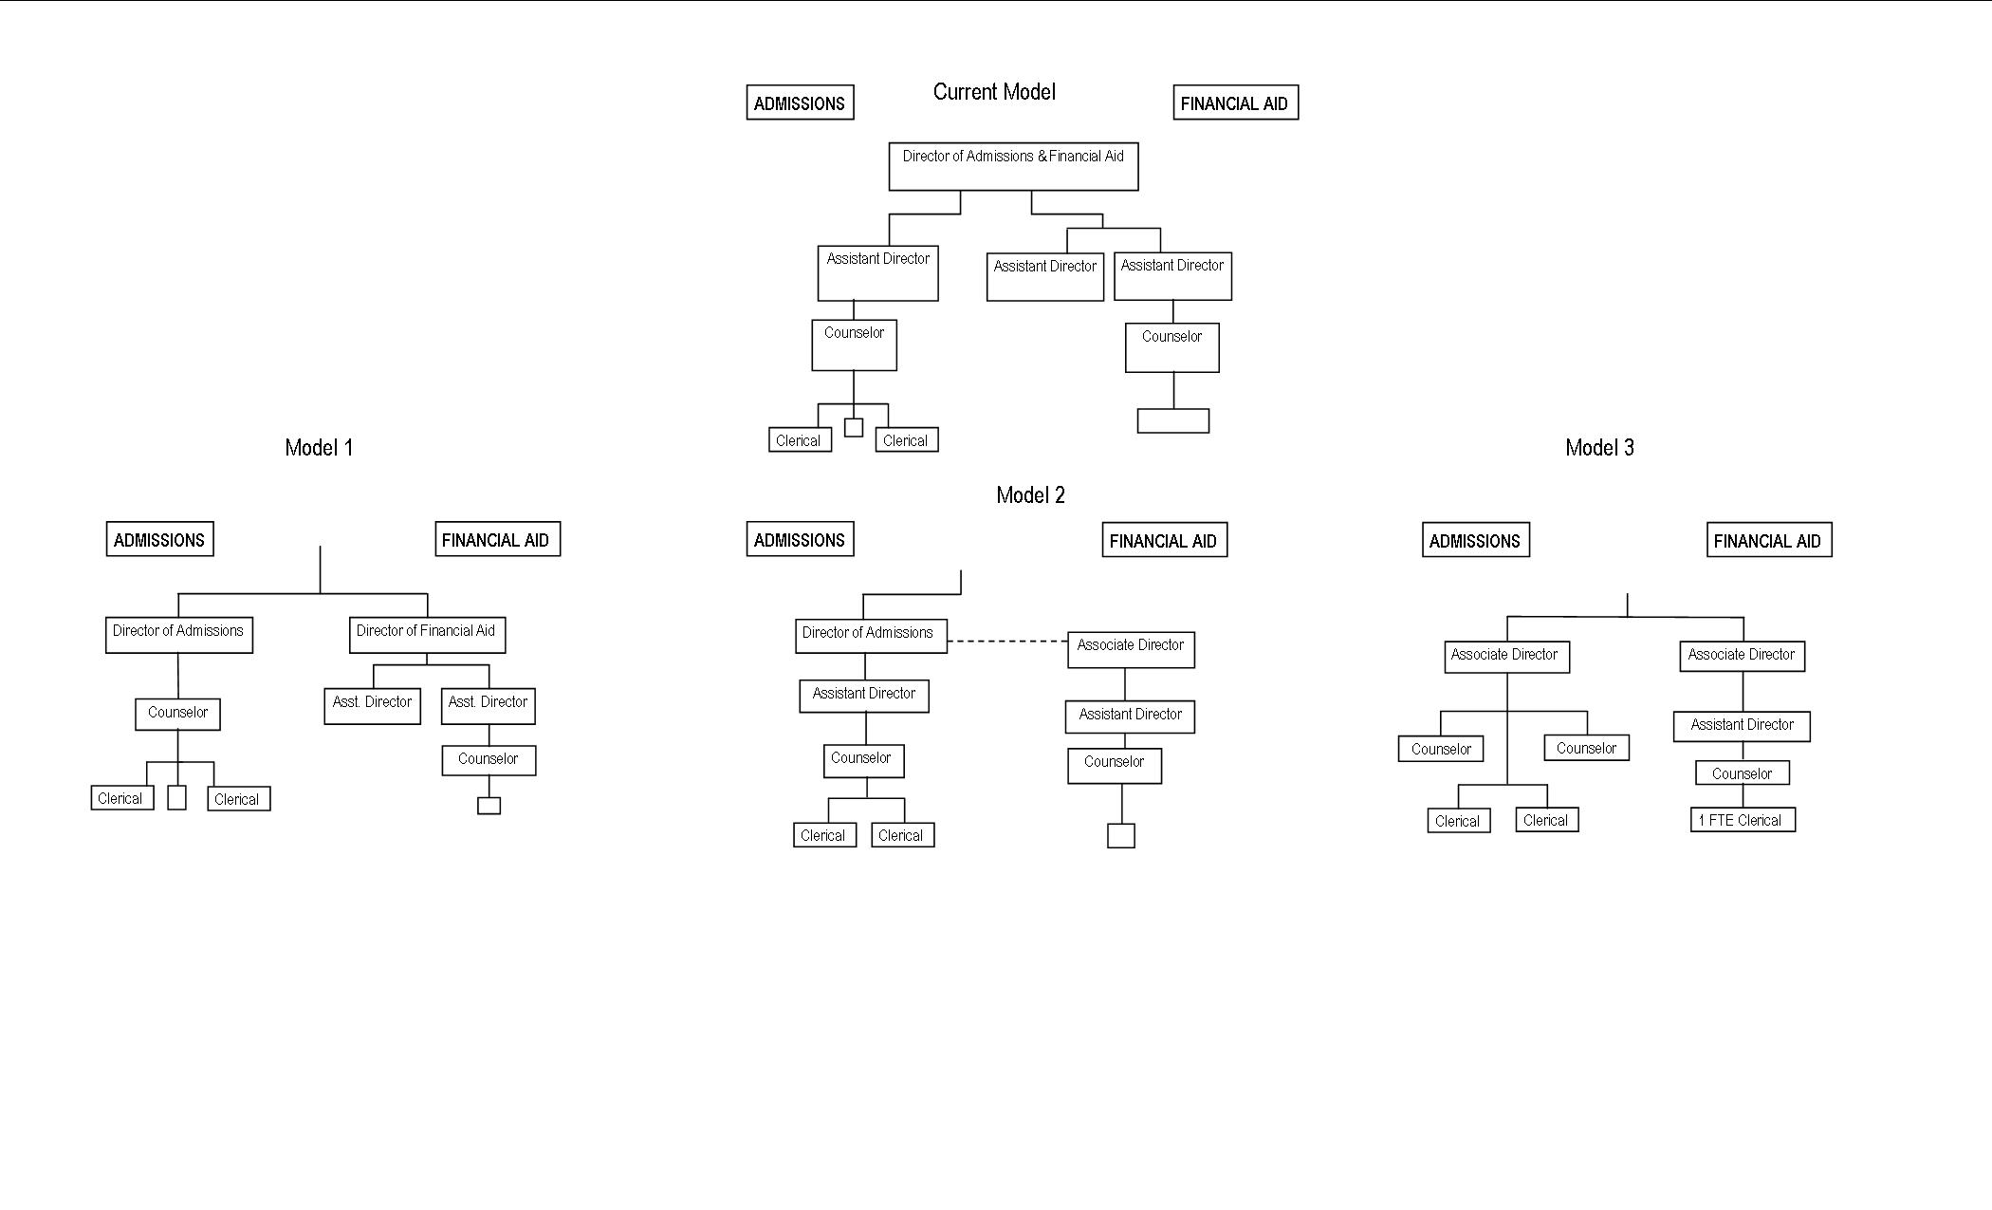

With the pending resignation of the current Director of Admission and Financial Aid VC Tharp brought before the Cabinet three models to consider for reorganizing both departments. VC Tharp noted that the current model of a Director for both departments has not worked effectively in the past two years. By adding a Director of Admissions, it would add strength and depth to the Admissions department but might diminish the Office of Financial Aid. VC Tharp pointed out that the regional campuses have had difficulties in recent years in hiring seasoned financial aid directors; 2 years ago IUS tapped a staff person from the Bursar’s office after failed searches and currently IUSB is reorganizing in part as a result of not being able to find an experienced financial aid director. The Bontrager report suggested we need another person in Admissions. By giving more back-office and automated tasks and processes to Student Enrollment Services (SES) in Bloomington, we would free up the two current Assistant Financial Aid Directors to enhance focus and have more contact time with students. VC Sehr expressed concern about additional charges for these services and Jim Kennedy (SES Director and IU AVP for Financial Aid) confirmed that most of these tasks are already included in our current fee assessment structure and he anticipates no additional costs at this time. IC Green was also concerned that without a campus director for Financial Aid to turn to, we would need ready access to someone with a high level of expertise and knowledge of laws and policies when we needed guidance. We were assured by AVP Kennedy that this would be provided centrally.

VC Sehr pointed out the 2009-10 budget is the same. Choosing model 3 which could be viewed as an evolving model can work and help existing personnel receive the experience, skills, and record of achievement to enable them to advance their careers. This model (3.) will also be more productive because there will be an additional counselor to visit schools and recruit students.

Jerre points out that all three models would work but model 3 is the best for us with our existing personnel and limited resources.

IC Green also points out that we must choose the model that enables us to be most competitive. The external environment has changed in regards to admissions and recruitment and it is highly competitive. Adding an Admissions counselor should help us attract more prospects that fit the campus profile. We need to concentrate more on outcomes as well as organizational structure.

After much discussion IC Green and the Cabinet approved Model 3. IC Green has also directed VC Tharp to report back to him next year about the restructuring to make sure it is working so he can share this information with the new chancellor.

